**fast2sms Procedure**

Step 1:

Type ‘ fast2sms ’ in google and click on the first link.

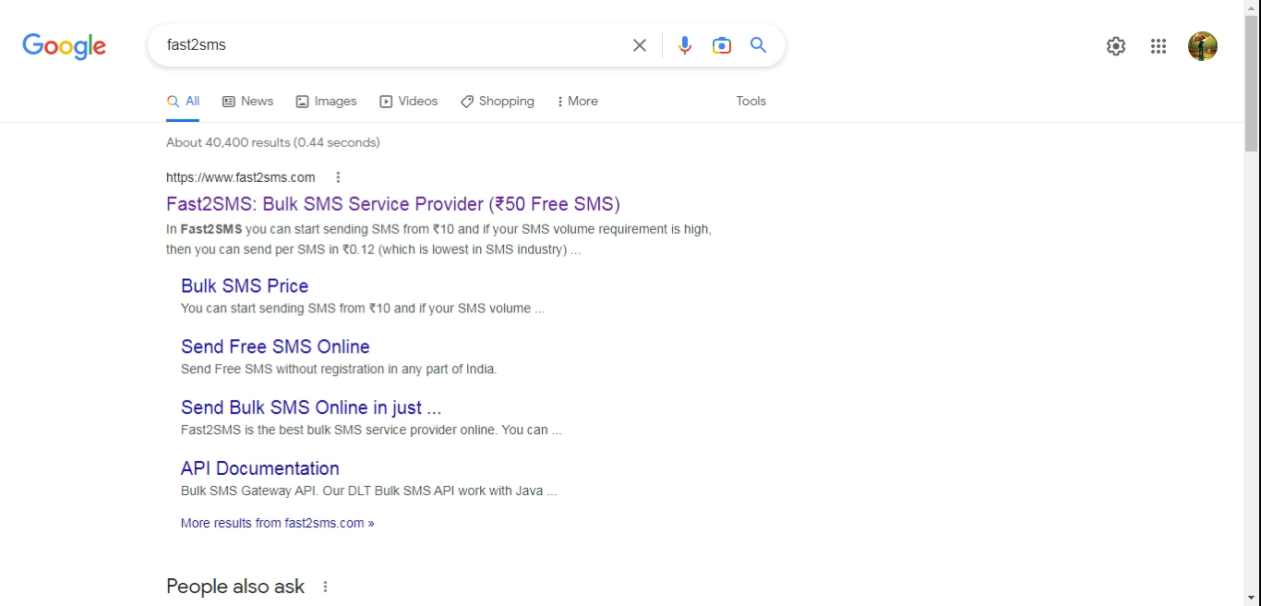

Step 2:

Click on sign up now.

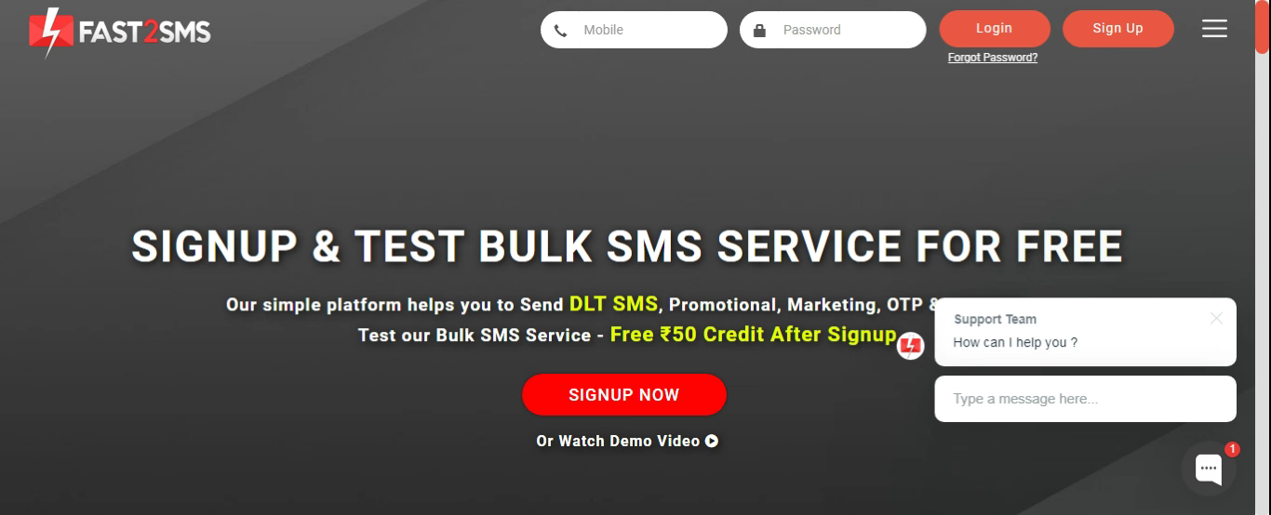

Step 3:

Give your details and click on the check box, then click on the submit button.

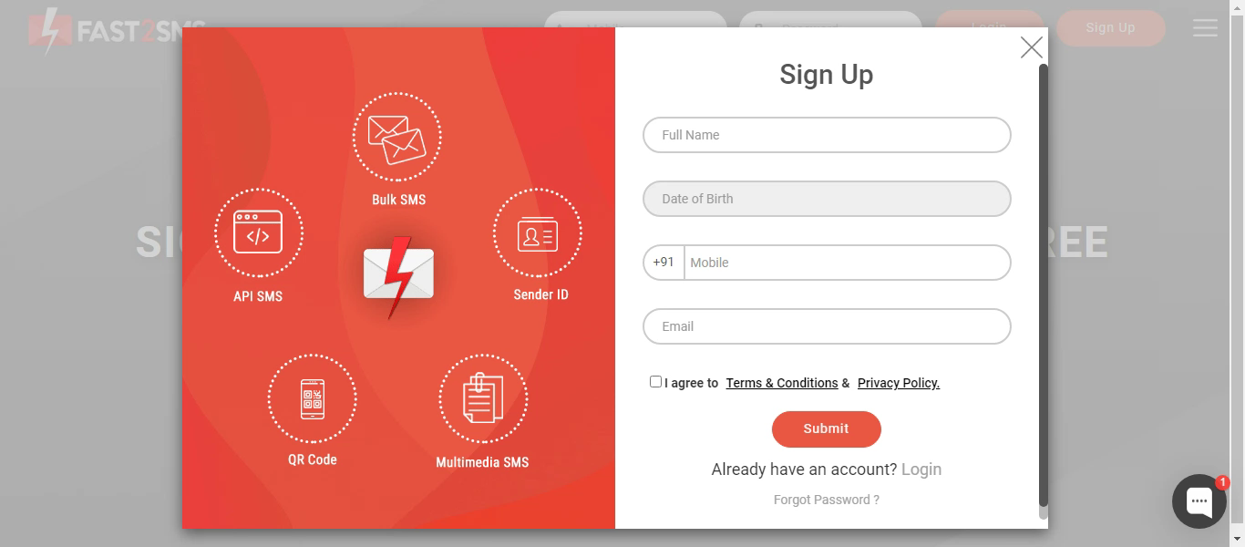

Step 4:

You will get the SMS with your password. Type your mobile number and the password then click on the submit button.

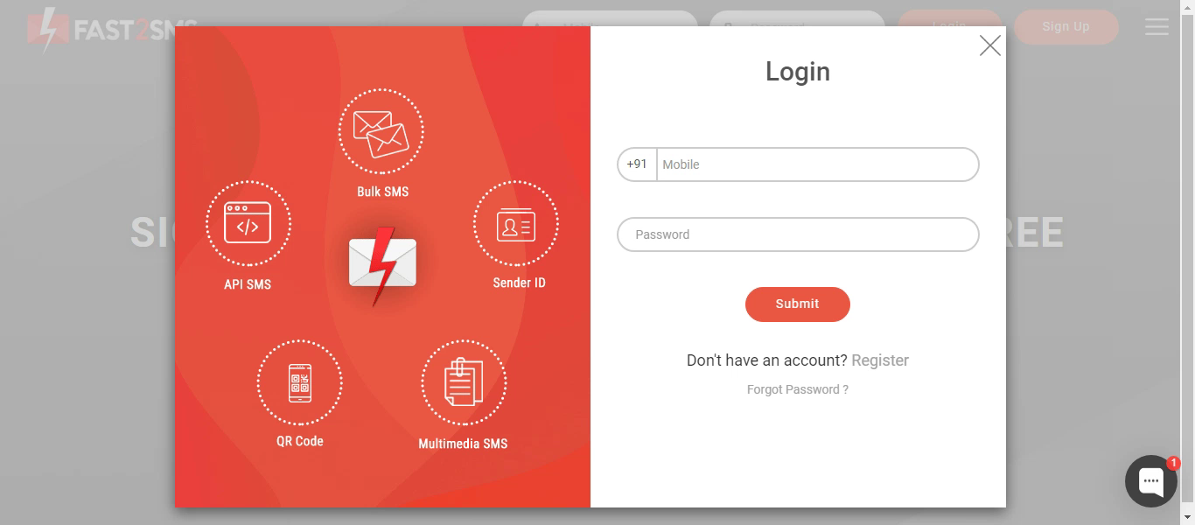

Step 5:

Click on the Dev API.

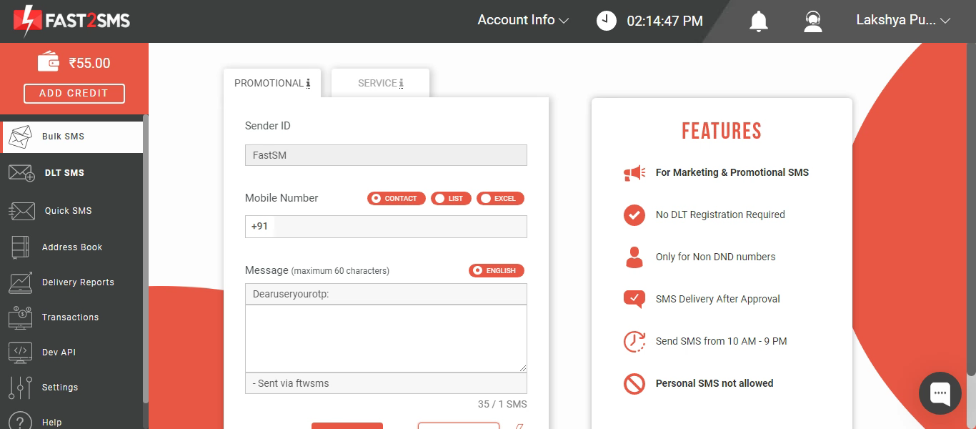

Step 6:

Select the Route as Quick SMS and type the message in message box.

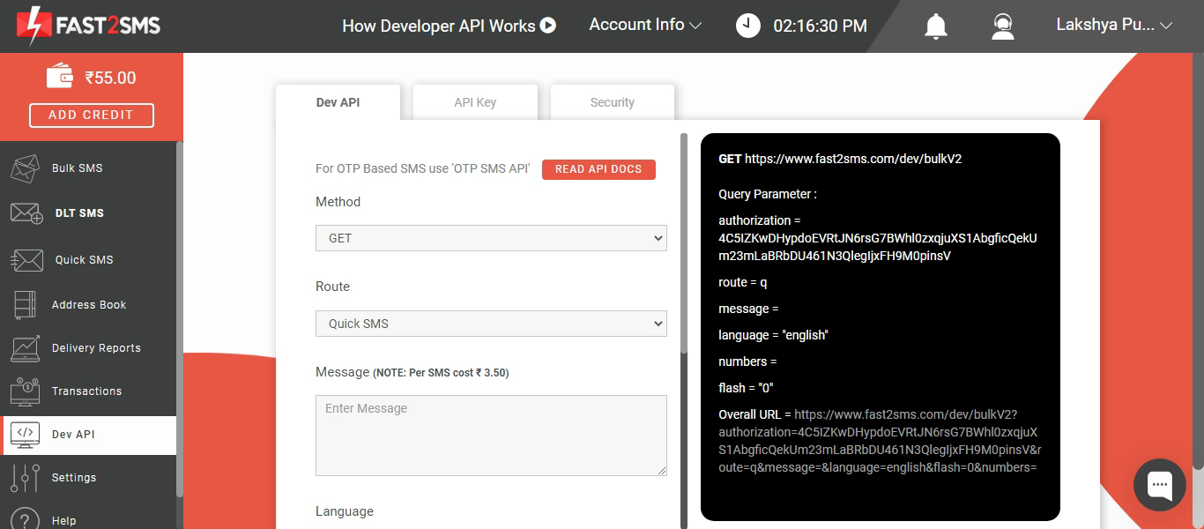

Step 7:

Select your language and type your mobile number in contact.

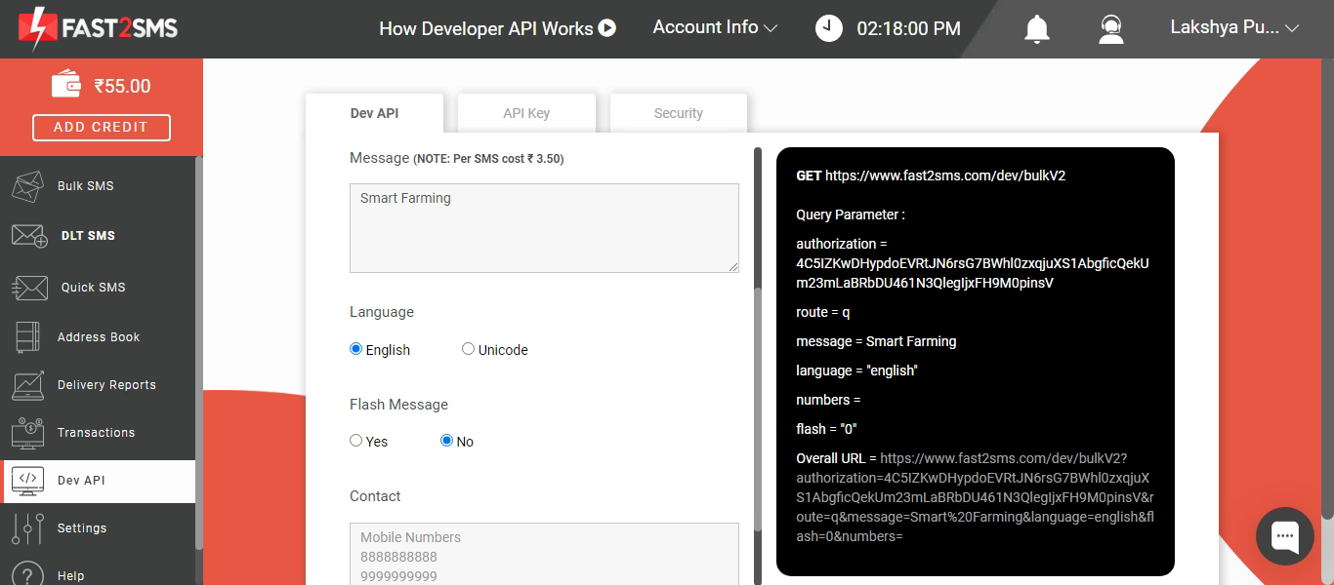

Step 8:

Copy the URL and paste it in the new tab.

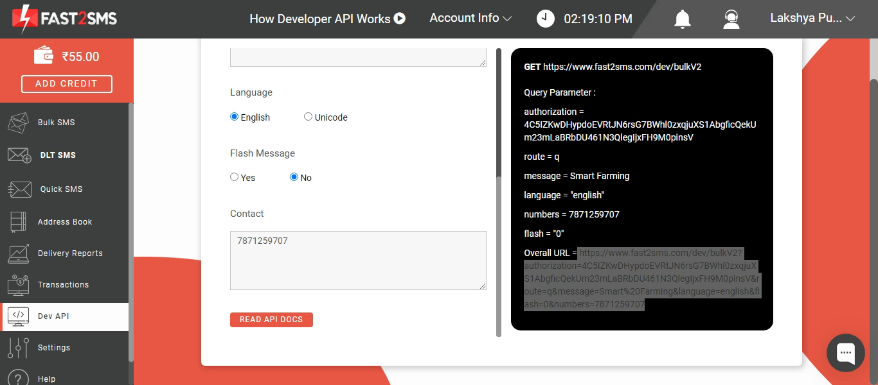

Step 9:

You will get the SMS in the new tab.

